**Stencil thickness**

For the choice of the stencil thickness (for solder paste), you can adhere to the following guidelines. Decisive is always the smallest component used. The final say should always have your assembler!

| **Type** | **Pitch** | **typical stencil thickness** |
| --- | --- | --- |
| BGA | 1,25mm | 150µm – 200µm |
| Finepitch BGA | 1,00mm | 115µm – 135µm |
| Finepitch BGA | 0,50mm | 75µm – 125µm |
| 0402 |  | 125µm – 150µm |
| 0201 |  | 75µm – 125µm |
| 01005 |  | 65µm – 90µm |
| PLCC | 1,25mm | 150µm – 250µm |
| QFP | 0,65mm | 150µm – 175µm |
| QFP | 0,50mm | 125µm – 150µm |
| QFP | 0,40mm | 100µm – 125µm |
| QFP | 0,30mm | 75µm – 125µm |

**Rule of thumb for detection of stencil thickness**

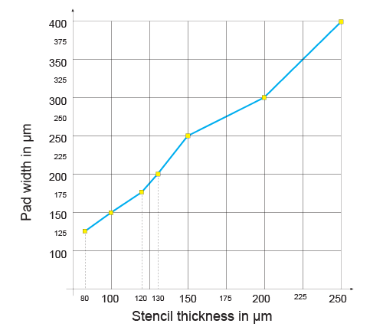

The stencil thickness shown is rounded down and adjusted to suit the available material thicknesses! The standard thickness is 150μm.

**Detection by aspect ratio and area ratio**

The calculation of necessary stencil thickness can also be made via aspect ratio and area. Recommended values:

| **Type** | **leaded** | **lead-free** |
| --- | --- | --- |
| Aspekt ratio | >1,5 | >1,7 |
| Area ratio | >0,66 | >0,8 |

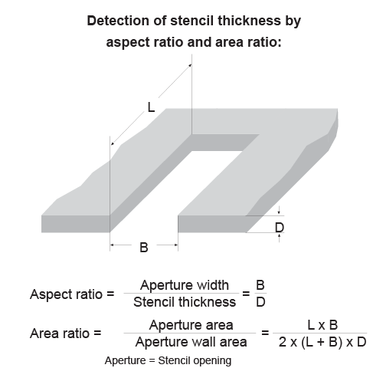

The thickness of **stencils for adhesive** is usually **250µm**.

**Stencil pads**

Stencils are generally lasered from the bottom-side. The production-related **conical cross-section** is then wider on the side opposite to the squeegee and allows a **better peeling** after the aplication of solder paste / adhesive (glue).

**Processing of the stencil pads**

Generally we recommend a **reduction of the stencil pads** (apertures) **by 10%**. This could be the done by the customer (with export of the paste data) or is done by us on request.  
  
**The following pad operations are carried out by Multi-CB on request:**

* Reduction of the pads by up to 10%
* Absolute circular reduction of the pads

**Modification of the pad form**

Generally, you should (along with your assembly) make a decision in respect of angular or rounded pads.  
  
If you have relatively large pad areas in your design, adding outbreak grids to apertures can help to reduce the adhesive forces.

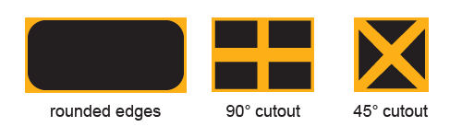

Possible changes of the pad form.

**Text on the stencil**

At Multi-CB the **text on the stencil is inclusive**. The text can be produced half lasered and lasered through.

**Half lasered text**

The SMD-Stencil will be turned for half lasered text, **half lasered text** is thus on the **top side** (squeegee side) of the stencil.

**Lasered-through text**

As the half lasered text, also the **lasered-through text** is cut from the bottom side. You can decide whether the text is readable from the **bottom or top side**. To ensure best stability, lasered text is executed in a special font which prevents breaking out of the letters.

Font for lasered text of a SMD stencil

Font for lasered text

**Positioning of PCB data on the SMD-Stencil**

[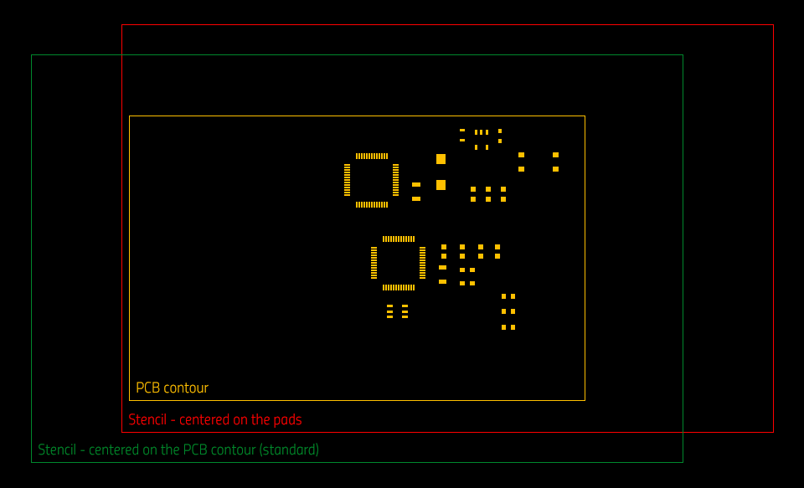](https://www.multi-circuit-boards.eu/fileadmin/img/03_Design-Hilfe/smd-schablone/smd-schablone_zentrierung_en.png)

The positioning of the PCB data on the SMD-Stencil follows this standard:

**A)** Customer sends stencil data with included contour / data positioning:

The positioning of the customer is used.

**B)** Only the PCB-(panel)contour is available:

The stencil is centered on the PCB contour.  
Advantage: The stencil covers the entire PCB

**C)**PCB-(panel)contour is not available:

The stencil is centered on the pads (paste data).

If your SMD-Stencil is to be manufactured **deviating from the standard** (e.g. centering the stencil on paste data with given board contour), please **indicate this in the notes**.

Standard layers for paste data / also recommended for stencil contour:

* [EAGLE](https://www.multi-circuit-boards.eu/en/support/pcb-data/eagle.html): tCream, bCream
* [Target](https://www.multi-circuit-boards.eu/en/support/pcb-data/target-3001.html): PasteTop, PasteBot
* Protel: GTP, GTB
* [KiCad](https://www.multi-circuit-boards.eu/en/support/pcb-data/kicad.html): f.paste, b.paste

**Stencil holder**

On request, we can add the required perforation to your stencil for all established, licence-free **quick clamping frames / holders**.  
  
Possible systems are amanongs others:

* QuattroFlex
* ZelFlex
* ESSEMTEC
* PAGGEN
* ...

In this case, please send us the data sheet of the quick clamp together with your order or [contact us](https://www.multi-circuit-boards.eu/en/contact.html).

**Tolerances**

| **Attribute** | **Tolerance** |
| --- | --- |
| Position accuracy | +/- 5µm |
| Accuracy of pad geometry | +/- 8µm |

**IPC handbook**

In the IPC-design directive for SMD stencils (IPC-7525A) is mentioned, as other applicable policy for the cleaning of stencils and misprinted printed circuit boards, IPC-7526 (Stencil and Misprinted Cleaning Handbook).   
  
This Directive is not commercially available and can be downloaded for free.  
  
[IPC-7526 – free download](https://www.multi-circuit-boards.eu/fileadmin/user_upload/downloads/leiterplatten_design-hilfe/ipc-7526.pdf" \t "_blank)

**Our service**

In the production of our **SMD laser stencils**, we place great value on **100% quality**. That's why we measure all the pads for **dimensional accuracy** and the real presence of the pads after production of your SMD stencil.

**Registration marks**

The application of**registration / fiducial marks** ensures the correct positioning of the stencil to the PCB, by the vision system of the assembly company.   
  
For vision systems operating **from below**, the registration marks are usually **half-lasered**. This is possible because SMD stencils are generally lasered from below.   
  
Does the vision system of the assembly company work **from above**, the registration marks are **lasered through**, just like a normal pad.   
  
The number of **registration marks** is specified by the customer, per single PCB **usually 3-4** pieces.   
  
**Typical types of registration marks:**

SMD stencil registration mark examples.

**Finishing treatment**

* **Inclusive**: Finish treatment by[double-sided brushing (deburring)](https://www.multi-circuit-boards.eu/en/products/smd-stencils/finishing-treatment.html#c2565) of the surface in allfour directions, giving reductionof the surface roughnessRzto about1µm. On request we can provide your stencil with a [circumferential Edge protection](https://www.multi-circuit-boards.eu/en/products/smd-stencils/finishing-treatment.html#c326).
* **Surcharge for**: Electropolish (good for middle series) and Nano protection (big series. See [SMD-Stencil finishing treatment](https://www.multi-circuit-boards.eu/en/products/smd-stencils/finishing-treatment.html).

**Additional information:**

* [SMD-Stencil finishing treatment](https://www.multi-circuit-boards.eu/en/products/smd-stencils/finishing-treatment.html)
* [Solder-stop](https://www.multi-circuit-boards.eu/en/pcb-design-aid/surface/solder-stop.html)
* [Printed Circuit Boards - Basic Design Rules](https://www.multi-circuit-boards.eu/en/pcb-design-aid/introduction.html)